**1.Installed Docker and Installed Minikube. Configured with chmod**

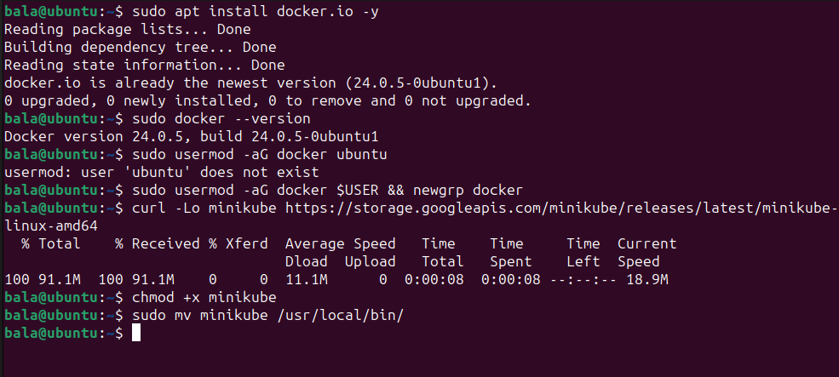

**2.Installed kubectl and configured with chmod**

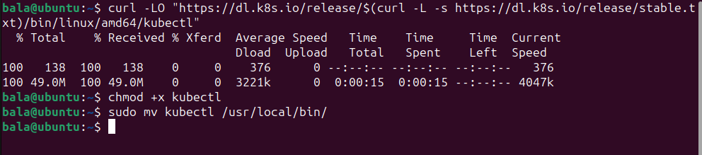

**3.Minikube Started & checked minikube status**

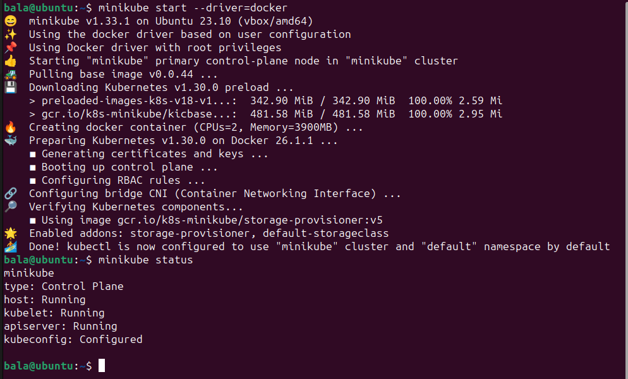

**4.kubectl commands**

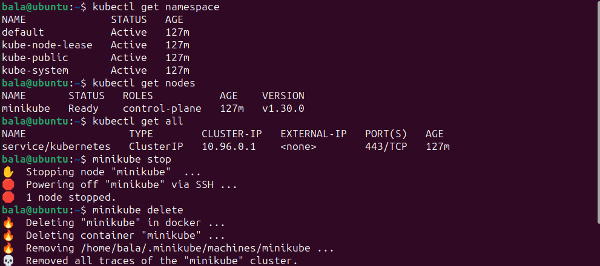

**5. Created manifest file for Namespace creation and Namespace (demo) created**

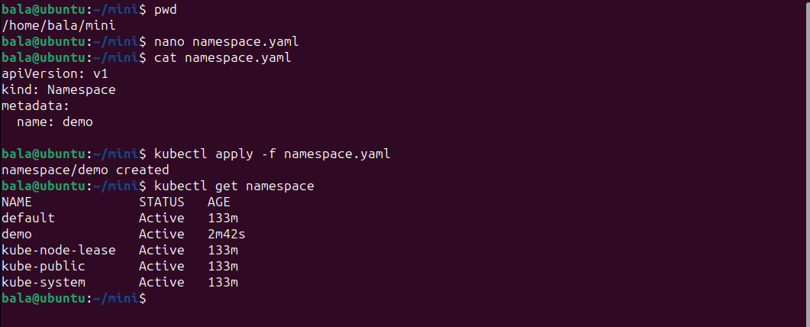

**6.Namespace creation using command line. Namespace (mydemo) created**

